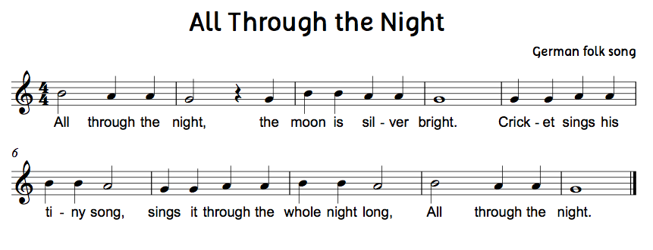

- Clap the rhythm
- Say the letter names while fingering on the recorder. (No playing yet)
- Play the song phrase by phrase.
- Play the whole song. Repeat until time is up.

- Clap the rhythm
- Say the letter names while fingering on the recorder. (No playing yet)
- Play the song phrase by phrase.
- Play the whole song. Repeat until time is up.
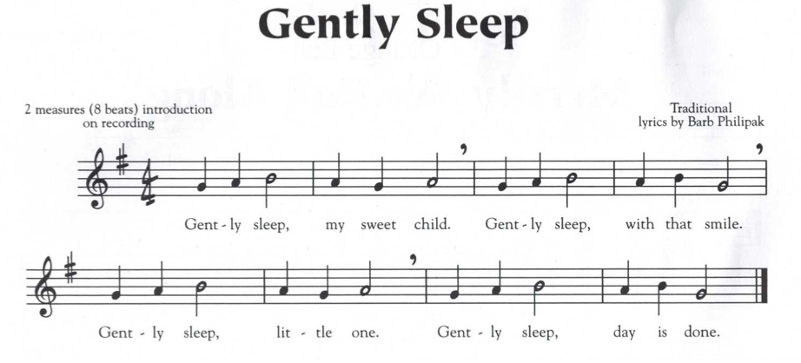
- Clap the rhythm
- Say the letter names while fingering on the recorder. (No playing yet)
- Play the song phrase by phrase.
- Play the whole song. Repeat until time is up.

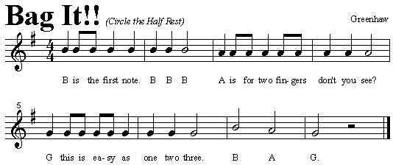

- Clap the rhythm
- Say the letter names while fingering on the recorder. (No playing yet)
- Play the song phrase by phrase.
- Play the whole song. Repeat until time is up.

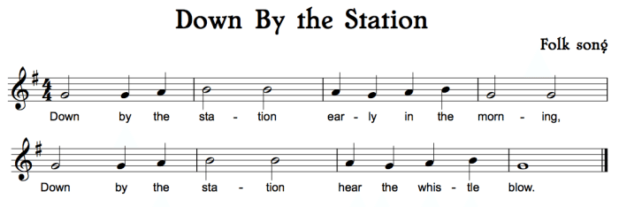

- Clap the rhythm
- Say the letter names while fingering on the recorder. (No playing yet)
- Play the song phrase by phrase.
- Play the whole song. Repeat until time is up.
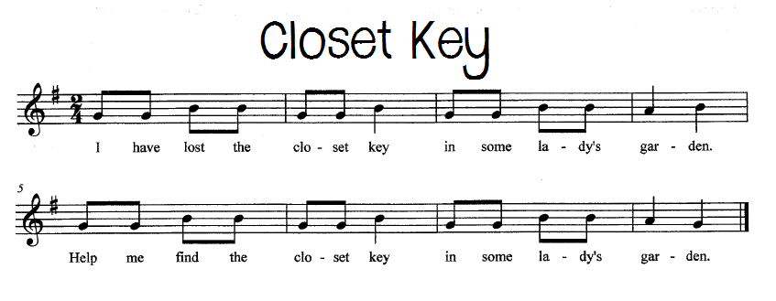

- Clap the rhythm
- Say the letter names while fingering on the recorder. (No playing yet)
- Play the song phrase by phrase.
- Play the whole song. Repeat until time is up.

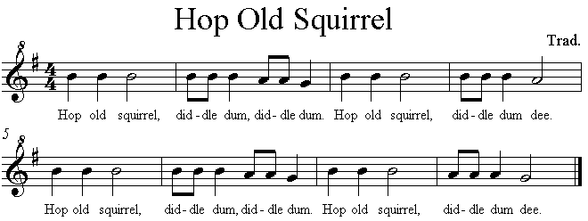

- Clap the rhythm
- Say the letter names while fingering on the recorder. (No playing yet)
- Play the song phrase by phrase.
- Play the whole song. Repeat until time is up.

